

NAME: Y .TEJANVESH REDDY
REG NO: 192425156
COURSE CODE: CSA06
COURSE NAME: DESIGN AND ANALYSIS OF ALGORITHMS

(a) Understand the problem
The input size \(n\) represents the number of products or data records processed by the platform. The dominant basic operation is the operation whose execution count determines the algorithm's growth rate.
Module | Input size | Dominant operation | Expected growth
M1 — Duplicate-Listing Detector | Number of products \(n\) | Comparing product titles and seller IDs | \(\Theta(n^2)\)
M2 — API Rate Limiter | Number of requests \(n\) | Audit(Request[j]) | \(\Theta(n)\)
M3 — Product Search S1 | Number of unsorted products \(n\) | Comparing the search key with a product | Best \(\Theta(1)\), worst \(\Theta(n)\)
M3 — Product Search S2 | Number of sorted index entries \(n\) | Comparing the key with the middle entry | \(\Theta(\log n)\)
M4 — Recommendation Engine | Number of customer–product records \(n\) | Recursive processing and merging | Current \(\Theta(n^2)\); redesigned \(\Theta(n\log n)\)
M5 — Sales Analytics Engine | Number of sales records \(n\) | Sorting and merging recursive subproblems | \(\Theta(n\log^2 n)\)

Justification: M1 examines every distinct pair of products. M2 processes request windows whose sizes double, so their total size is a geometric series. S1 may examine every catalogue entry, while S2 repeatedly halves the search space. M4 and M5 are analyzed using their given recurrence relations.

(b) Analyse the iterative modules
M1 — Duplicate-Listing Detector
The algorithm compares each product with every product appearing later in the catalogue.
The outer loop runs for \(i=0,1,\ldots,n-2\). For a fixed \(i\), the inner loop performs \(n-i-1\) comparisons.
Therefore,
\[ \begin{aligned} C(n)&=\sum_{i=0}^{n-2}(n-i-1)\\ &=(n-1)+(n-2)+\cdots+2+1\\ &=\sum_{k=1}^{n-1}k\\ &=\frac{n(n-1)}{2}\\ &=\frac{n^2-n}{2}. \end{aligned} \]
The dominant term is \(\frac12 n^2\).
- Exact comparison count: \(\frac{n(n-1)}2\)
- Best, average and worst time complexity: \(\Theta(n^2)\), because the nested loops perform the same number of pair comparisons regardless of whether duplicates are found.
- Auxiliary space complexity: \(O(1)\), excluding storage for the catalogue and duplicate markers.
Interpretation: Doubling the catalogue size makes the number of pair comparisons approximately four times larger. This is a major scalability concern.
M2 — API Rate Limiter
The outer loop starts with \(i=1\) and doubles \(i\) on every iteration. The inner loop performs exactly \(i\) audit operations.
The audit counts are therefore
\[ 1+2+4+8+\cdots+2^k, \]
where \(2^k<n\) and \(2^{k+1}\ge n\).
Let
\[ k=\lfloor\log_2(n-1)\rfloor. \]
Using the geometric-series formula,
\[ \begin{aligned} A(n)&=\sum_{r=0}^{k}2^r\\ &=\frac{2^{k+1}-1}{2-1}\\ &=2^{k+1}-1\\ &=2^{\lfloor\log_2(n-1)\rfloor+1}-1. \end{aligned} \]
Thus, the exact number of audit operations is
\[ \boxed{A(n)=2^{\lfloor\log_2(n-1)\rfloor+1}-1} \]
for integer \(n\ge2\), with \(A(1)=0\).
Is the team's \(\Theta(n\log n)\) claim correct?
No. Although the outer loop executes \(\Theta(\log n)\) times, the inner loop's sizes are not all \(n\). Their sum is a geometric series:
\[ n-1\le A(n)<2n. \]
Hence,
\[ \boxed{A(n)=\Theta(n)}. \]
The algorithm is linear, not \(\Theta(n\log n)\).
Verification for \(n=1024\)
The loop uses the values \(i=1,2,4,\ldots,512\).
\[ \begin{aligned} A(1024)&=1+2+4+\cdots+512\\ &=2^{10}-1\\ &=\boxed{1023}. \end{aligned} \]
The loop stops when \(i=1024\), because its condition \(i<n\) is then false.

(c) Solve S2 by backward substitution
The recurrence for binary search is
\[ T(n)=T(n/2)+1,\qquad T(1)=1. \]
The constant \(1\) represents one key comparison at each level.
Step 1: Expand the recurrence
\[ \begin{aligned} T(n)&=T(n/2)+1\\ &=T(n/4)+1+1\\ &=T(n/8)+1+1+1\\ &=T(n/2^k)+k. \end{aligned} \]
Step 2: Find the stopping level
The recursion reaches the base case when
\[ \frac{n}{2^k}=1. \]
Therefore,
\[ n=2^k \]
and
\[ k=\log_2 n. \]
Step 3: Substitute the base case
Since \(T(1)=1\),
\[ \begin{aligned} T(n)&=T(1)+\log_2 n\\ &=1+\log_2 n. \end{aligned} \]
For powers of two, the exact closed form is
\[ \boxed{T(n)=\log_2 n+1}. \]
For arbitrary integer sizes, the usual binary-search comparison count is bounded by \(\Theta(\log n)\); the precise count depends on the search implementation and its stopping convention.
Complexity comparison
Implementation | Time | Auxiliary space
Iterative binary search | \(\Theta(\log n)\) | \(O(1)\)
Recursive binary search | \(\Theta(\log n)\) | \(O(\log n)\) call stack
The iterative version avoids recursive call-stack overhead. Both versions achieve logarithmic search time on a sorted index.

(d) Apply the Master Theorem
The Master Theorem applies to recurrences of the form
\[ T(n)=aT(n/b)+f(n). \]
We compare \(f(n)\) with \(n^{\log_b a}\).
M4 — Current recommendation engine
Given:
\[ T(n)=4T(n/2)+n. \]
Identify the parameters:
- \(a=4\)
- \(b=2\)
- \(f(n)=n\)
Calculate the comparison term:
\[ n^{\log_b a}=n^{\log_2 4}=n^2. \]
Compare:
\[ f(n)=n=O(n^{2-1}). \]
This satisfies Master Theorem Case 1, so
\[ \boxed{T(n)=\Theta(n^2)}. \]
The replicated partitions cause four recursive subproblems of size \(n/2\), leading to quadratic growth.
M4 — Proposed redesign
The redesigned recurrence is
\[ T(n)=2T(n/2)+n. \]
Parameters:
- \(a=2\)
- \(b=2\)
- \(f(n)=n\)
Calculate:
\[ n^{\log_b a}=n^{\log_2 2}=n. \]
Since \(f(n)=\Theta(n)\), this satisfies Master Theorem Case 2, giving
\[ \boxed{T(n)=\Theta(n\log n)}. \]
Removing the replication reduces the asymptotic growth from quadratic to linearithmic.
What happens when the data doubles?
For the current design, the dominant term is quadratic:
\[ \frac{(2n)^2}{n^2}=4. \]
The running time increases by approximately four times.
For the redesign, the dominant term is \(n\log_2 n\):
\[ \frac{2n\log_2(2n)}{n\log_2 n} =2\left(1+\frac{1}{\log_2 n}\right). \]
This ratio approaches 2 as \(n\) becomes large. The redesigned algorithm's running time therefore grows approximately twofold when the data doubles.
M5 — Sales analytics engine
The recurrence is
\[ T(n)=2T(n/2)+n\log_2 n. \]
Parameters:
- \(a=2\)
- \(b=2\)
- \(f(n)=n\log_2 n\)
Calculate:
\[ n^{\log_b a}=n^{\log_2 2}=n. \]
The ordinary three-case Master Theorem, in its basic form, does not directly cover the logarithmic factor in \(f(n)=\Theta(n\log n)\). Use the extended Master Theorem or a recursion tree.
Recursion-tree derivation
At level \(i\), there are \(2^i\) subproblems, each of size \(n/2^i\).
The work at that level is
\[ \begin{aligned} W_i &=2^i\left(\frac{n}{2^i} \log_2\frac{n}{2^i}\right)\\ &=n(\log_2 n-i). \end{aligned} \]
Let \(L=\log_2 n\), assuming \(n\) is a power of two. Summing the internal-level work,
\[ \begin{aligned} T(n) &\propto n\sum_{i=0}^{L-1}(L-i)\\ &=n(1+2+\cdots+L)\\ &=\frac{nL(L+1)}2. \end{aligned} \]
Consequently,
\[ T(n)=\Theta(nL^2) \]
and the final result is
\[ \boxed{T(n)=\Theta(n\log^2 n)}. \]
The sales analytics engine is asymptotically more expensive than a conventional \(\Theta(n\log n)\) sorting algorithm, but it is still far more scalable than a quadratic algorithm.

(e) Analyse best, average and worst cases
S1 — Sequential search
S1 searches an unsorted catalogue from the first entry to the last.
Case | Input condition | Number of comparisons
Best | The product is the first entry | \(1\)
Average, if present | The product is equally likely to occupy any position | \((n+1)/2\)
Worst | The product is the last entry, or is absent | \(n\)
If the product exists with probability \(p\), assume that when it exists, each of the \(n\) positions is equally likely. When it does not exist, the algorithm scans all \(n\) entries.
Therefore,
\[ \begin{aligned} E[C(n)] &=p\frac{n+1}{2}+(1-p)n\\ &=\frac{p(n+1)}2+n-pn\\ &=\boxed{n-\frac{p(n-1)}2}. \end{aligned} \]
For \(n=1{,}000{,}000\) and \(p=0.5\),
\[ \begin{aligned} E[C(n)] &=1{,}000{,}000 -\frac{0.5(999{,}999)}2\\ &=1{,}000{,}000-249{,}999.75\\ &=\boxed{750{,}000.25}. \end{aligned} \]
The expected count is approximately 750,000 comparisons.
S2 — Binary search
S2 searches a sorted index by repeatedly comparing the key with the middle entry.
Case | Input condition | Number of comparisons
Best | The key is the first middle entry checked | \(1\)
Average | The key is distributed among possible positions, with a balanced search tree | \(\Theta(\log n)\)
Worst | The key is at the deepest search level, or absent and requires the deepest search path | \(\Theta(\log n)\)
For an exact power-of-two input under the supplied recurrence, the worst-case count is \(\log_2 n+1\). For arbitrary input sizes, the precise count depends on the implementation, but its growth remains logarithmic.
Comparison: S1's worst-case running time is \(\Theta(n)\), whereas S2's is \(\Theta(\log n)\). For a catalogue containing one million products, the sorted index can reduce the number of comparisons dramatically.

(f) Prove the asymptotic bound formally
The nightly report generator has the cost function
\[ f(n)=3n^2+10n\log_2 n+50. \]
We must prove that \(f(n)=\Theta(n^2)\), then show that \(f(n)\notin O(n)\).
Step 1 — Prove the lower bound
For all integers \(n\ge1\), the logarithmic term and constant term are nonnegative. Thus,
\[ f(n)=3n^2+10n\log_2 n+50\ge3n^2. \]
Choose
\[ c_1=3. \]
Therefore,
\[ f(n)\ge c_1n^2 \]
for all \(n\ge1\).
Step 2 — Prove the upper bound
For \(n\ge1\), we use the inequality
\[ \log_2 n\le n. \]
Hence,
\[ 10n\log_2 n\le10n^2. \]
Also, \(50\le50n^2\). Combining the bounds,
\[ \begin{aligned} f(n)&=3n^2+10n\log_2 n+50\\ &\le3n^2+10n^2+50n^2\\ &=63n^2. \end{aligned} \]
Choose
\[ c_2=63. \]
Therefore,
\[ f(n)\le c_2n^2 \]
for all \(n\ge1\).
Step 3 — State the constants and conclusion
The formal definition of \(\Theta(n^2)\) requires positive constants \(c_1,c_2\) and an integer \(n_0\) such that
\[ 0\le c_1n^2\le f(n)\le c_2n^2 \]
for every \(n\ge n_0\).
Our choices are
\[ \boxed{c_1=3,\quad c_2=63,\quad n_0=1}. \]
Both inequalities hold, so
\[ \boxed{f(n)=\Theta(n^2)}. \]
Step 4 — Show that \(f(n)\) is not \(O(n)\)
Suppose, for contradiction, that \(f(n)=O(n)\). By definition, there would be constants \(C>0\) and \(n_0\) such that
\[ f(n)\le Cn \]
for every \(n\ge n_0\).
But \(f(n)\ge3n^2\), so this would imply
\[ 3n^2\le Cn. \]
For \(n>0\), divide both sides by \(n\):
\[ 3n\le C. \]
This cannot hold for all sufficiently large \(n\), because \(3n\) grows without bound while \(C\) is fixed.
Therefore, the assumption is false:
\[ \boxed{f(n)\notin O(n)}. \]
The report generator is quadratic, not linear.

(g) Scalability decision
The assessment specifies a server capable of \(10^8\) basic operations per second. The following estimates use the dominant operation counts and the supplied recurrences.
The running-time estimate is
\[ \text{Time in seconds} =\frac{\text{Number of basic operations}}{10^8}. \]
The nightly deadline is 10 minutes, or 600 seconds.
Estimated operations at \(n=1{,}000{,}000\)
M5's count is an asymptotic recursion-tree estimate; exact operation counts depend on the recurrence's base case and implementation.
Module | Operation-count estimate | Estimated time | Within 600 seconds?
M1 — Duplicate detector | \(499{,}999{,}500{,}000\) comparisons | \(4{,}999.995\) s (83.33 min) | No
M2 — Rate limiter | \(1{,}048{,}575\) audits | \(0.01049\) s | Yes
M3 S2 — Binary search | About 20–21 comparisons per search | About \(0.0000002\) s per search | Yes
M4 — Current design | Proportional to \(n^2=10^{12}\) | About \(10{,}000\) s (166.67 min) | No
M4 — Redesigned | Proportional to \(n\log_2 n\) | About \(0.1993\) s | Yes
M5 — Sales analytics | About \(208.6\) million level operations | About \(2.09\) s | Yes
Important qualification: For M4 and M5, the recurrences omit some implementation details and base-case costs. Their times are model-based estimates, not measured production runtimes. The M4 coefficients shown assume the recurrence's non-recursive work is \(n\) operations at each call.

Modules that must be redesigned
M1 — Duplicate-Listing Detector
Its approximately 5,000 seconds exceed the 600-second deadline. Replace all-pairs comparisons with a hash-based grouping strategy using a composite key such as (seller, normalized_title). Expected processing time can be reduced to \(\Theta(n)\) with suitable hashing assumptions, at the cost of additional memory.
M4 — Recommendation Engine
The current quadratic design is estimated at 10,000 seconds. Remove unnecessary replicated subproblems as proposed, reducing the recurrence from \(4T(n/2)+n\) to \(2T(n/2)+n\). This improves the growth rate to \(\Theta(n\log n)\).
M2, S2 and M5 — Retain, with validation
Their estimated operation counts fit within the deadline under the given model. Preserve the linear rate limiter and logarithmic search. Profile M5 on realistic workloads to validate the recursion-tree estimate before deployment.
The audit therefore identifies M1 and the current M4 design as the two modules that must be redesigned first.
Python code and expected outputs
The following program verifies the main mathematical results in the assessment without running billions of actual comparisons. It calculates the counts using formulas, which is much faster and avoids unnecessary memory usage.
1. Complete verification program
Create a Python file named shopsphere_audit.py and enter the following code.
while largest_power * 2 < n: largest_power *= 2 return 2 * largest_power - 1def binary_search_comparisons(n): """Worst-case comparison estimate from the supplied recurrence.""" if n <= 0: return 0 return math.ceil(math.log2(n)) + 1def m4_current_operations(n): """Quadratic-order model for the current recommendation engine.""" return n ** 2def m4_redesign_operations(n): """Linearithmic-order model for the redesigned engine.""" return n * math.log2(n)def m5_operations(n): """Recursion-tree estimate for n a power of two. Extended as an asymptotic estimate for other n. """ if n <= 1: return 1 level = math.log2(n) return n * level * (level + 1) / 2def seconds(operations): return operations / SERVER_SPEEDdef show_result(name, operations): time_taken = seconds(operations) status = "PASS" if time_taken <= DEADLINE else "FAIL" print(f"{name}") print(f" Operations: {operations:,.2f}") print(f" Time: {time_taken:,.6f} seconds") print(f" Deadline: {status}") print()# Part (b): M1 and M2print("PART B: ITERATIVE MODULES")print("M1 comparisons for n=10:", m1_comparisons(10))print("M2 audits for n=1024:", m2_audits(1024))print("M2 audits for n=1000000:", m2_audits(1_000_000))print()# Part (c): S2print("PART C: BINARY SEARCH")print("S2 worst-case estimate for n=1000000:", binary_search_comparisons(1_000_000))print()# Part (e): S1 expected comparisonsn = 1_000_000p = 0.5expected_s1 = n - p * (n - 1) / 2print("PART E: SEQUENTIAL SEARCH")
2. Expected output
The output should be approximately as follows. Small differences may occur because of floating-point rounding.

PART B: ITERATIVE MODULES
M1 comparisons for n=10: 45
M2 audits for n=1024: 1023
M2 audits for n=1000000: 1048575

PART C: BINARY SEARCH
S2 worst-case estimate for n=1000000: 21

PART E: SEQUENTIAL SEARCH
Expected S1 comparisons: 750,000.25

PART F: THETA PROOF
c1 = 3, c2 = 63, n0 = 1
f(n) = Theta(n^2), and f(n) is not O(n)

PART G: SCALABILITY AUDIT

M1: Duplicate detector
Operations: 499,999,500,000.00
Time: 4999.995000 seconds
Deadline: FAIL

M2: Rate limiter
Operations: 1,048,575.00
Time: 0.010486 seconds
Deadline: PASS

M4: Current design
Operations: 1,000,000,000,000.00
Time: 10000.000000 seconds
Deadline: FAIL

M4: Redesigned model
Operations: 19,931,568.57
Time: 0.199316 seconds
Deadline: PASS

M5: Analytics estimate
Operations: 208,599,497.10
Time: 2.085995 seconds
Deadline: PASS
Code note: The M4 and M5 functions estimate costs from their asymptotic models, not exact counts from a fully specified implementation. The S2 function likewise reports a recurrence-based estimate, not an exact count for every binary-search implementation. M2's function returns the exact count for the given loop.

Final conclusion
The ShopSphere audit demonstrates why asymptotic analysis is essential before a catalogue grows from 100,000 to one million products.
- M1 has quadratic growth and exceeds the nightly deadline. Redesign it using hashing or grouping.
- M2 has linear growth, despite the incorrect \(\Theta(n\log n)\) claim.
- S2 provides logarithmic search and is substantially more scalable than sequential search.
- M4 should remove replicated recursive work, reducing its growth from \(\Theta(n^2)\) to \(\Theta(n\log n)\).
- M5 has \(\Theta(n\log^2 n)\) growth under the supplied recurrence and fits the estimated processing window.
The highest-priority changes are the duplicate detector and the current recommendation engine. Actual deployment decisions should also be validated through profiling, since the server-speed assumption does not account for database access, network latency, storage, or parallel execution.
INPUT :
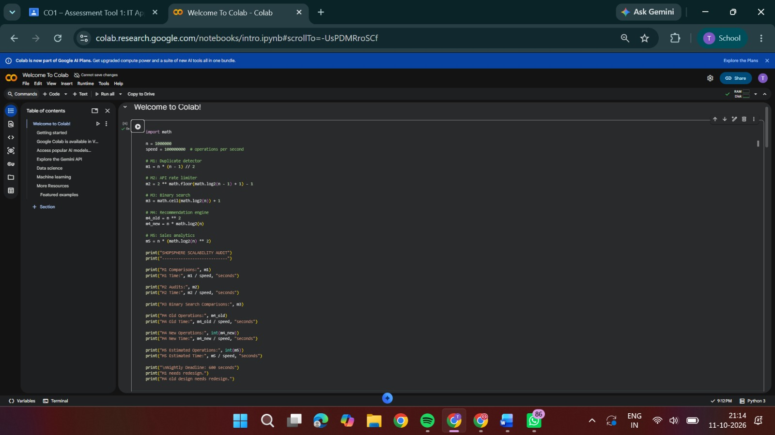
OUTPUT:
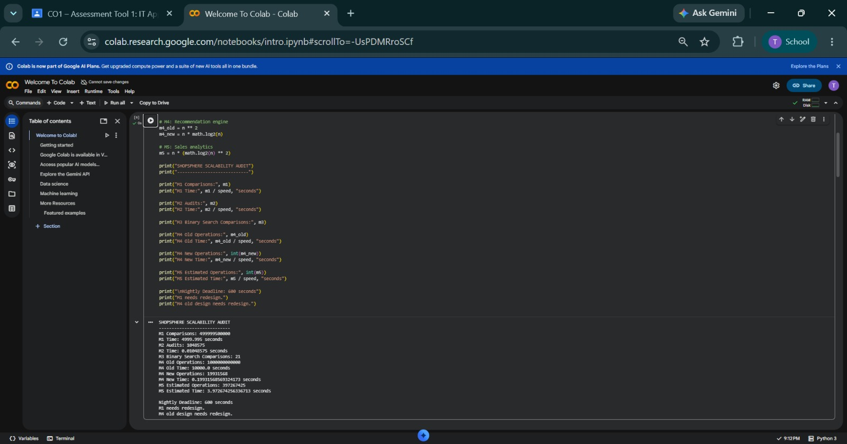
Code of Conduct
I Y. Tejanvesh Reddy/ 192425156(Name / Reg. No.) certify that this submission is my original
work and that I have adhered to the guidelines specified for this assessment. I understand that any
violation of academic integrity rules will result in disciplinary action.
Signature of the Student: Tejanvesh reddy Date: 11/10/26

